AFRIRESQ
Architecture
How the new system is put together. The hi-fi prototype is the source for look and flow. Light and dark are the same screens, with a color choice.

The look
We do not use Bootstrap, Tailwind, or a ready-made theme. The screens are written in our own CSS so the product keeps the face from the prototype.
Titles use Fraunces. Everything else uses Figtree. The light theme is ivory and deep green, with gold as a quiet accent and red only for urgent help. The dark theme is the same layout on a near-black green. A person switches color in the app. Nothing else changes.
The hi-fi light and hi-fi dark boards are one design. We build each screen once and theme it.

Phone and laptop
The first product is a website. The same site opens on a phone browser and on a laptop. On a phone it is the full-screen help flow from the prototype. On a laptop the same flow uses the wider page: readable type, the same steps, and room for a desk to see cases. It is one web app, not a phone frame pasted onto a desktop.
Android and iOS apps come later. They will use this same API. They are not part of this build, and there is no mobile-app folder yet.

What the system is
One product. A person joins as a citizen or as a student, fills one profile, and opens a case. Medical help is the full path. Other emergencies use the same account, the same location, and the same case, on a shorter path. A desk accepts the case. The map stays inside the site.
- Citizen: Uganda phone number, confirmed by SMS code.
- Student: university from the directory, then a code to the university email. A phone number is still saved so a desk can call.
- Profile, in three steps: about you, people and places, then the medical card. The card is shared only while a case is open.
- Medical path: a student can start at their university hospital. Everyone can use the nearest place or go there themselves. An ambulance is offered only when that place is connected.
- Other types: road accident, fire, security, missing person, disaster, and other. They go to their own desk. They do not send a medical ambulance.
- Safety Net is optional. Walk me home shares a live trip with a trusted person, who can see an alert. It can be skipped at signup.
- Coming back: sign in with a code, a welcome-back screen, and lock the app.
- 999 and 112 stay one tap. They are a phone call, not a feature we dispatch.

The picture
A person, a desk, and later a coordinator use one web app, on a phone or a laptop. The app talks only to our API. The API stores the truth in PostgreSQL, pushes live updates over a WebSocket, and sends signup codes through SMS and email. The map is drawn in the app.
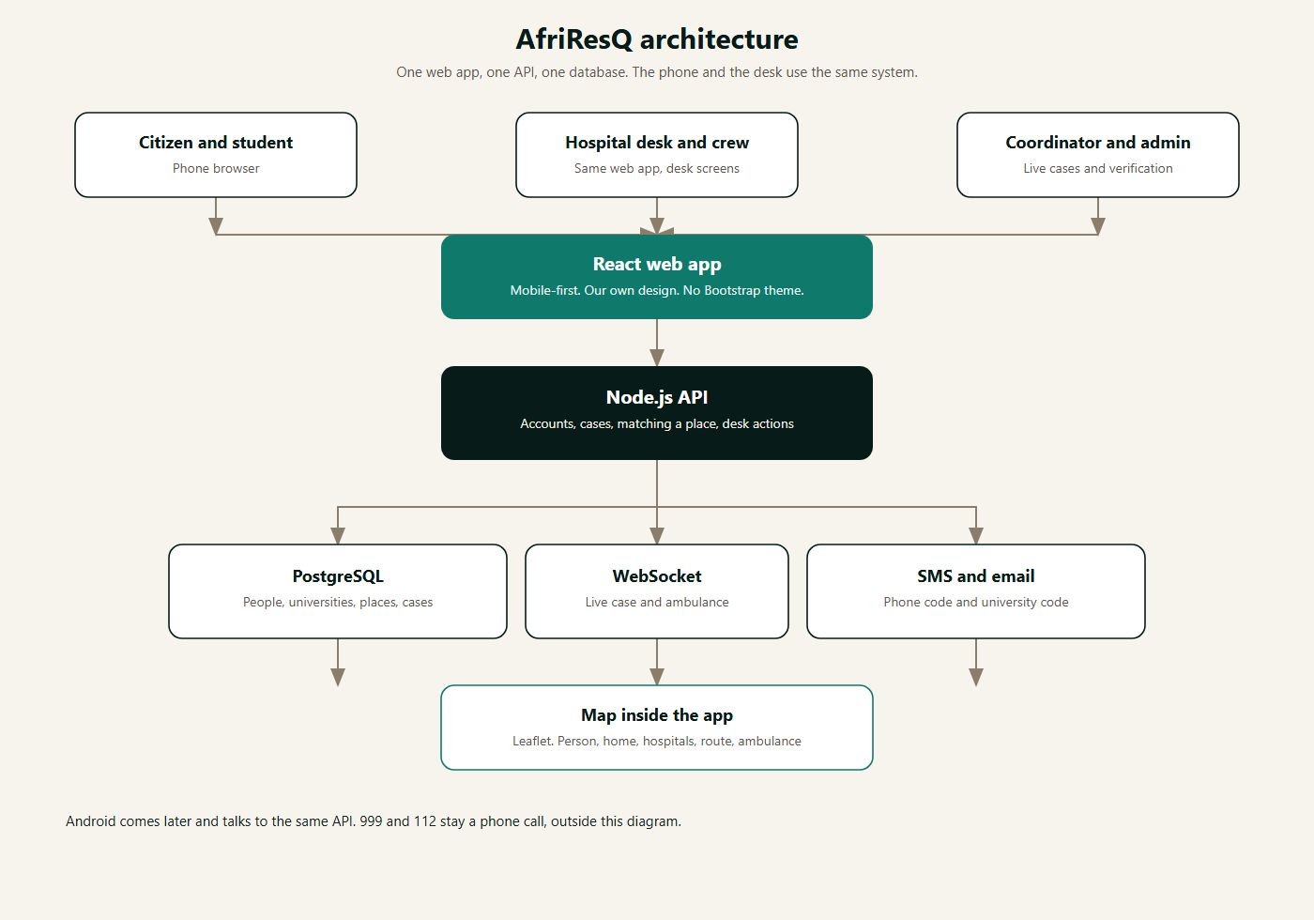
Figure 1. AfriResQ architecture. The first build is the website. Android and iOS come later and use this same API.

Where the work lives
The new system is in its own folder. It is not the old GitHub repository. The old code stays on GitHub if it is needed again.
Folder | What is in it
docs | This architecture, the system diagram, and the explanation of how the product works.
frontend | The website. Phone and laptop. React and Vite, our own CSS, light and dark.
backend | The server. Node.js and Express. The only place that decides what is allowed.

What we use
Piece | Choice | Why this one
Website | React and Vite | One site for a person and a desk, on a phone and on a laptop.
Look | Our own CSS | No Bootstrap, no Tailwind, no theme kit. Light and dark are a color switch.
API | Node.js and Express | Accounts, cases, places, and desk actions live in one service.
Database | PostgreSQL | People, universities, places, and cases need a real database.
Live updates | WebSocket | The case, the ambulance, the trip, and the desk change without a refresh.
Map | Leaflet | Person, home pin, hospitals, route, and ambulance, inside the site.
Citizen code | SMS, Africa’s Talking | The phone number is also how a desk calls them.
Student code | Email to the university domain | Makerere first, addresses ending in mak.ac.ug. Other universities stay listed.
Android and iOS | Later, same API | Not in this build. The website already runs on a phone.

The parts

Website
The person and the desk open the same site. On a phone it follows the prototype, screen by screen. On a laptop the same steps sit in a wider layout, and a desk login uses that width for incoming cases. The site does not talk to the database. Every read and write goes through the API. The color choice is stored on the device.

API
The API is the only place that decides what is allowed. It confirms codes, saves the profile, opens a case, chooses whether a place can send an ambulance, records each step from sent to closed, and shares a Walk me home trip only with the trusted person. Medical details leave the API only for the place handling an open case.

Database
PostgreSQL holds users, universities and their allowed email domains, places and whether they are connected, cases, case events, the medical card, and Safety Net contacts. Live GPS for an open case or an active walk is stored with that case or trip and stops being shared when it ends.

Realtime
When a desk accepts, a crew moves, a person starts a route, or a walk shares a new position, the API publishes that change on a WebSocket. The phone, the laptop, and the desk all listen. Refreshing the page is a backup.

Codes and calls
A citizen code is an SMS. A student code is an email to the university domain for the university they picked. Until those providers are connected, a development mode can accept a fixed demo code so the flow can be built. Production does not ship with that switch on.

Flows from the prototype
The lo-fi and both hi-fi boards tell the same story. Citizen and student are variants of the same screens. The student home has a university hospital card. The citizen home does not.
- First time: welcome, join, phone or university plus email, code, then profile in three steps, then Safety Net consent or skip.
- Coming back: sign in, welcome back, and lock.
- Medical: report, then help options. A student has three choices, including the university hospital. A citizen has two. A connected place can send an ambulance. A listed place offers a call and a route only. Go there yourself is turn-by-turn. The case runs Sent, Accepted, On the way, then Closed.
- Other emergencies go to a desk. The desk sees a connected case and a case that is not connected, which can be marked handled.
- Safety Net: Walk me home starts sharing. The trusted person sees an alert preview.

A case through the system
The person sends a medical report with what happened, who is with them, and a location. The API opens one case and attaches the nearest places. If the chosen place is connected, the desk can dispatch an ambulance. If it is only listed, the API refuses dispatch and the site offers a call and a route. A student may start from their university hospital. That is a shortcut to a place, not a second system.
Other emergency types create the same kind of case with a different desk. They never call the ambulance action.
State | Who moves it
Sent | The person. The desk can see it.
Accepted | The desk, or a crew.
On the way | The ambulance moving, or the person on the route.
Arrived | The crew, or the person.
Closed | The person can leave a rating. Sharing of location and the medical card stops.

Who can do what
Role | Can
Citizen | Create an account, keep a profile, open a case, follow a route, cancel before arrival, use Safety Net.
Student | Everything a citizen can do, plus contact their university hospital first.
Desk | See cases for their place, accept, call, dispatch an ambulance if the place is connected, mark a case handled when it is not.
Coordinator | See live cases, verify a desk or a student, and look back at closed cases. Built after the desk.
Admin | Manage universities, places, and who is a coordinator.

Order of building
- Prototype reviewed. Light and dark are one design plus a color choice. This document matches that prototype.
- Folder organized: docs, frontend, and backend.
- Website shell: our CSS, light and dark, and a layout that works on a phone and on a laptop.
- Citizen and student signup, the code, then the three-step profile and Safety Net consent.
- Medical report, map, nearest place, university hospital, route, ambulance, and the case through to closed.
- Desk screens: connected dispatch, and mark handled when the place is not connected.
- Other emergency types, Walk me home, then coordinator tools.
- Android and iOS only after the website is the full product.
If a later screen in the prototype disagrees with this document, the prototype wins on look and flow, and this document is updated before that screen is built.

